**Task Description**

The task includes -

* Creating AWS EC2 instance
* Connecting to AWS EC2 instance using SSH using PuTTY

About **EC2 – Elastic Cloud Compute :**

Amazon Elastic Compute Cloud (Amazon EC2) is a web service that provides resizable compute capacity in the cloud. It is designed to make web-scale cloud computing easier for developers. You can use Amazon EC2 to launch as many or as few virtual servers as you need, configure security and networking, and manage storage. Amazon EC2 enables you to scale up or down to handle changes in requirements or spikes in popularity, reducing your need to forecast traffic.

* **Virtual servers**: Amazon Elastic Compute Cloud (EC2) provides resizable compute capacity in the cloud using virtual servers.
* **Wide range of instance types**: EC2 offers a variety of instance types with different hardware specifications to suit different workload requirements.
* **Scalability**: EC2 allows users to easily scale their computing resources up or down as needed using APIs or the AWS Management Console.
* **Storage options**: EC2 instances can be launched with local instance storage, Amazon Elastic Block Store (EBS) volumes, and Amazon S3.
* **Customization**: Users can customize the networking, security, and runtime environment of their EC2 instances using Amazon Machine Images (AMIs) and configuration files.
* **Wide range of applications**: EC2 instances can be used for a variety of applications, including web and application servers, data processing, and machine learning.
* **Pay-as-you-go pricing**: Users pay for EC2 instances on a per-hour or per-second basis, depending on the instance type and usage.
* **Cost optimization**: EC2 offers features such as reserved instances, spot instances, and auto scaling to help users optimize their costs.
* **Key component of AWS cloud**: EC2 is a key component of the AWS cloud platform and is used by many organizations around the world.
* **Reliability**: EC2 is a reliable and secure platform for hosting applications and workloads in the cloud.

**Screenshots of the tasks :**

* Creating Linux EC2 instance

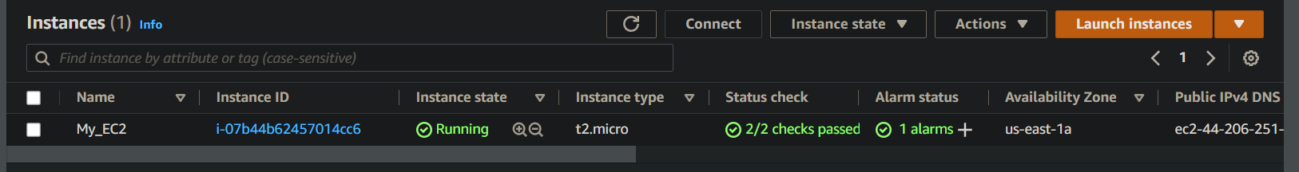

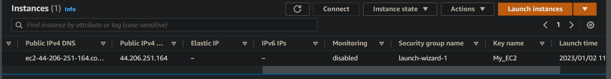

Successfully created EC2 instance with desired configuration

* EC2 instance summary

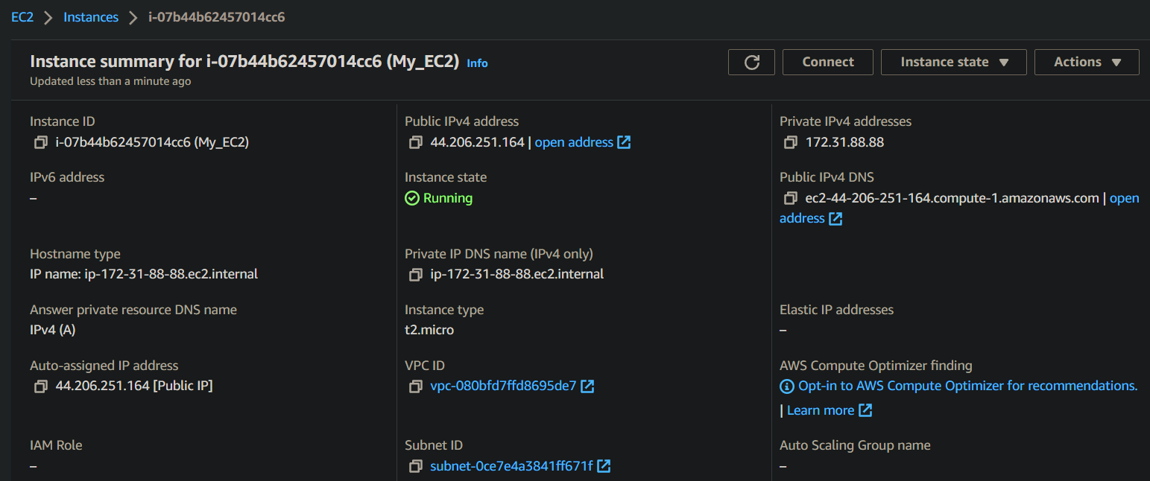

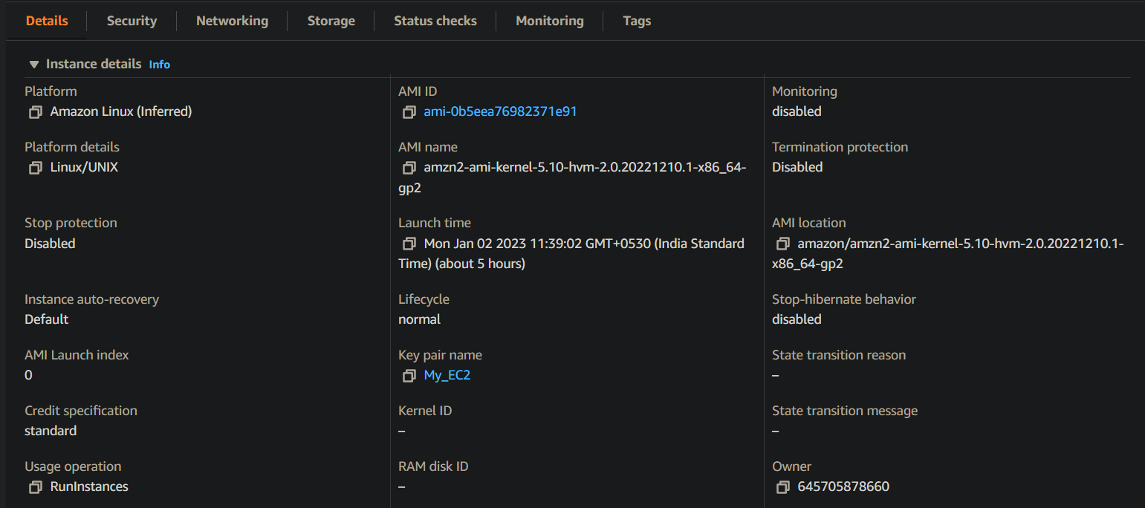

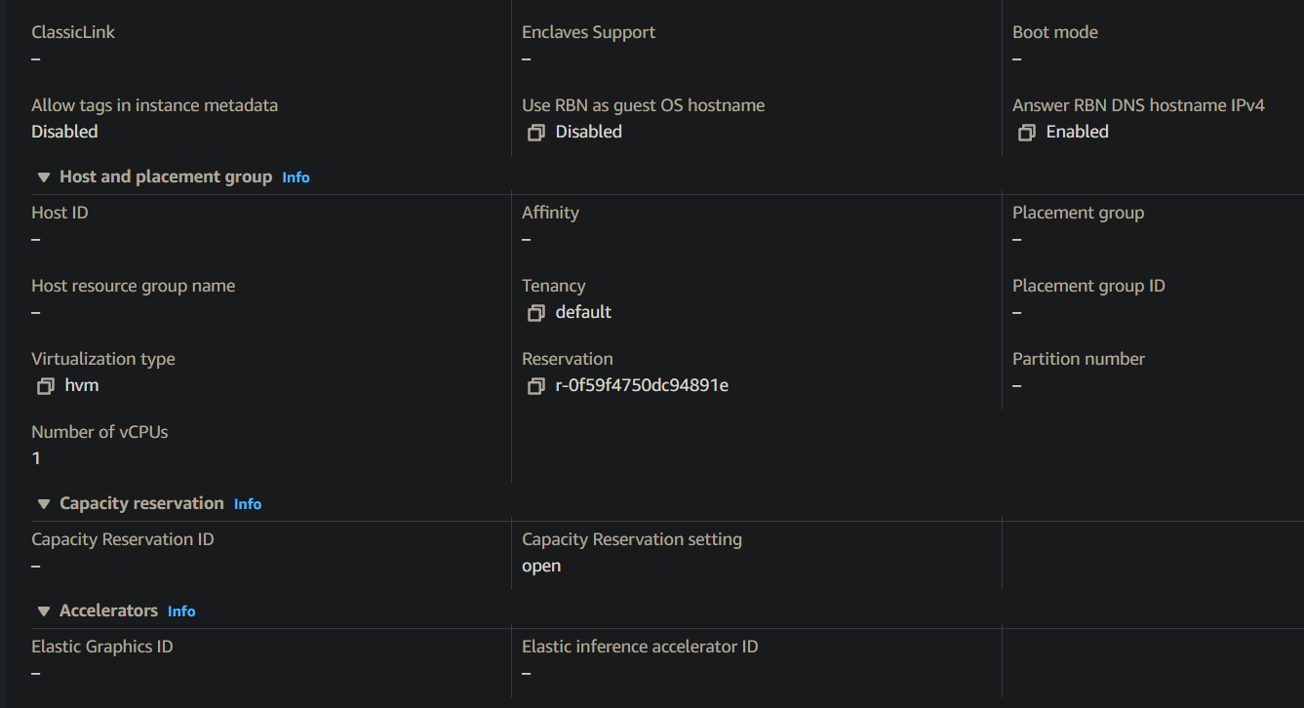

Successfully created EC2 instances with desired configuration

* Security Configuration

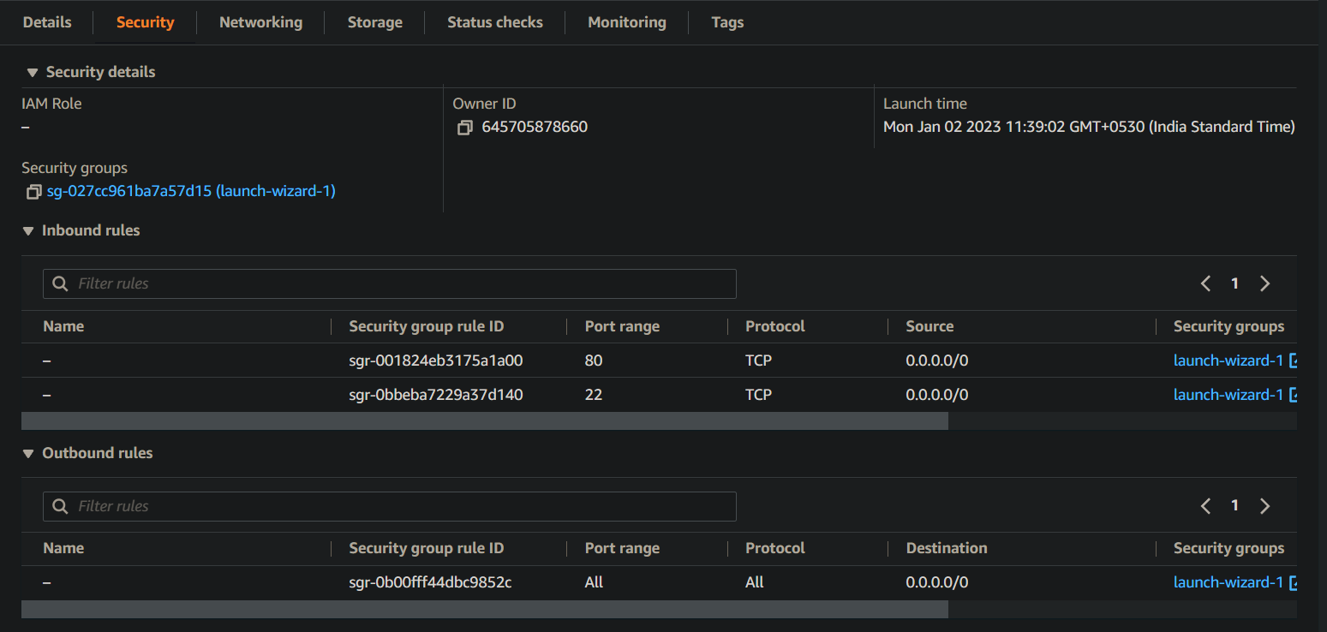

Successfully created security groups

* Networking Configuration

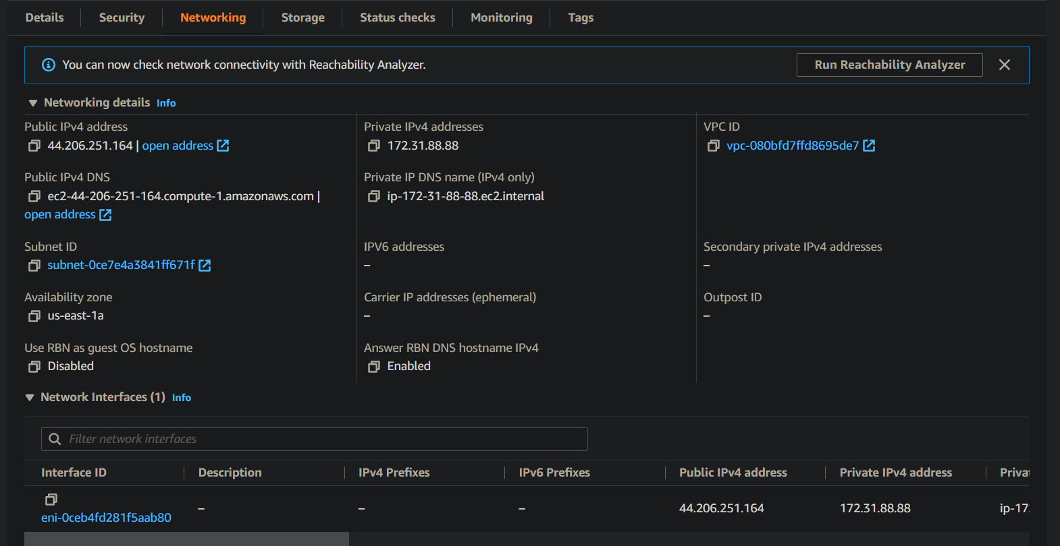

Successfully configured networking details

* Establishing connection with EC2 instance

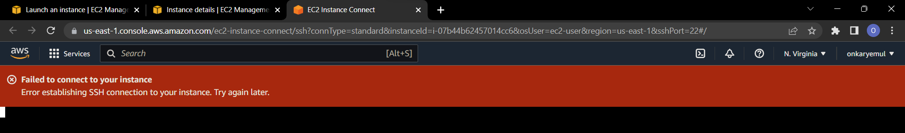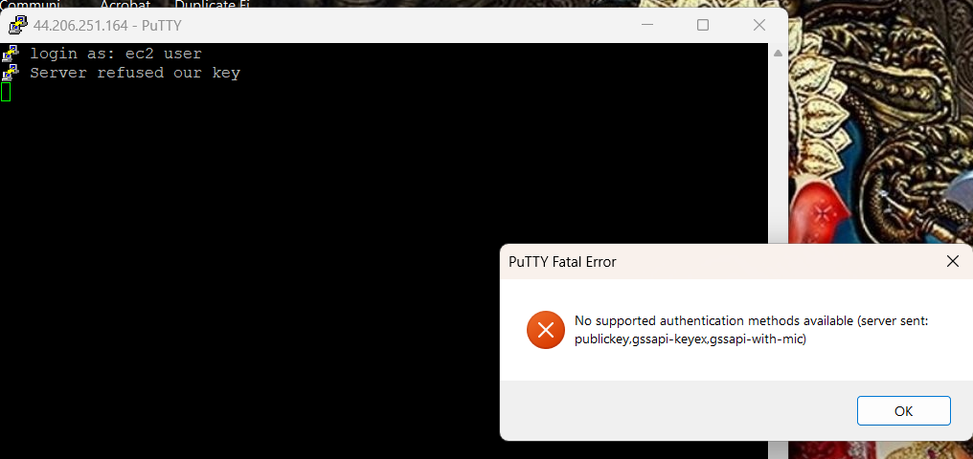

Successfully completed the task!

**Here’s IP of my task**

**44.206.251.164 [public ip]**

THANK YOU!!